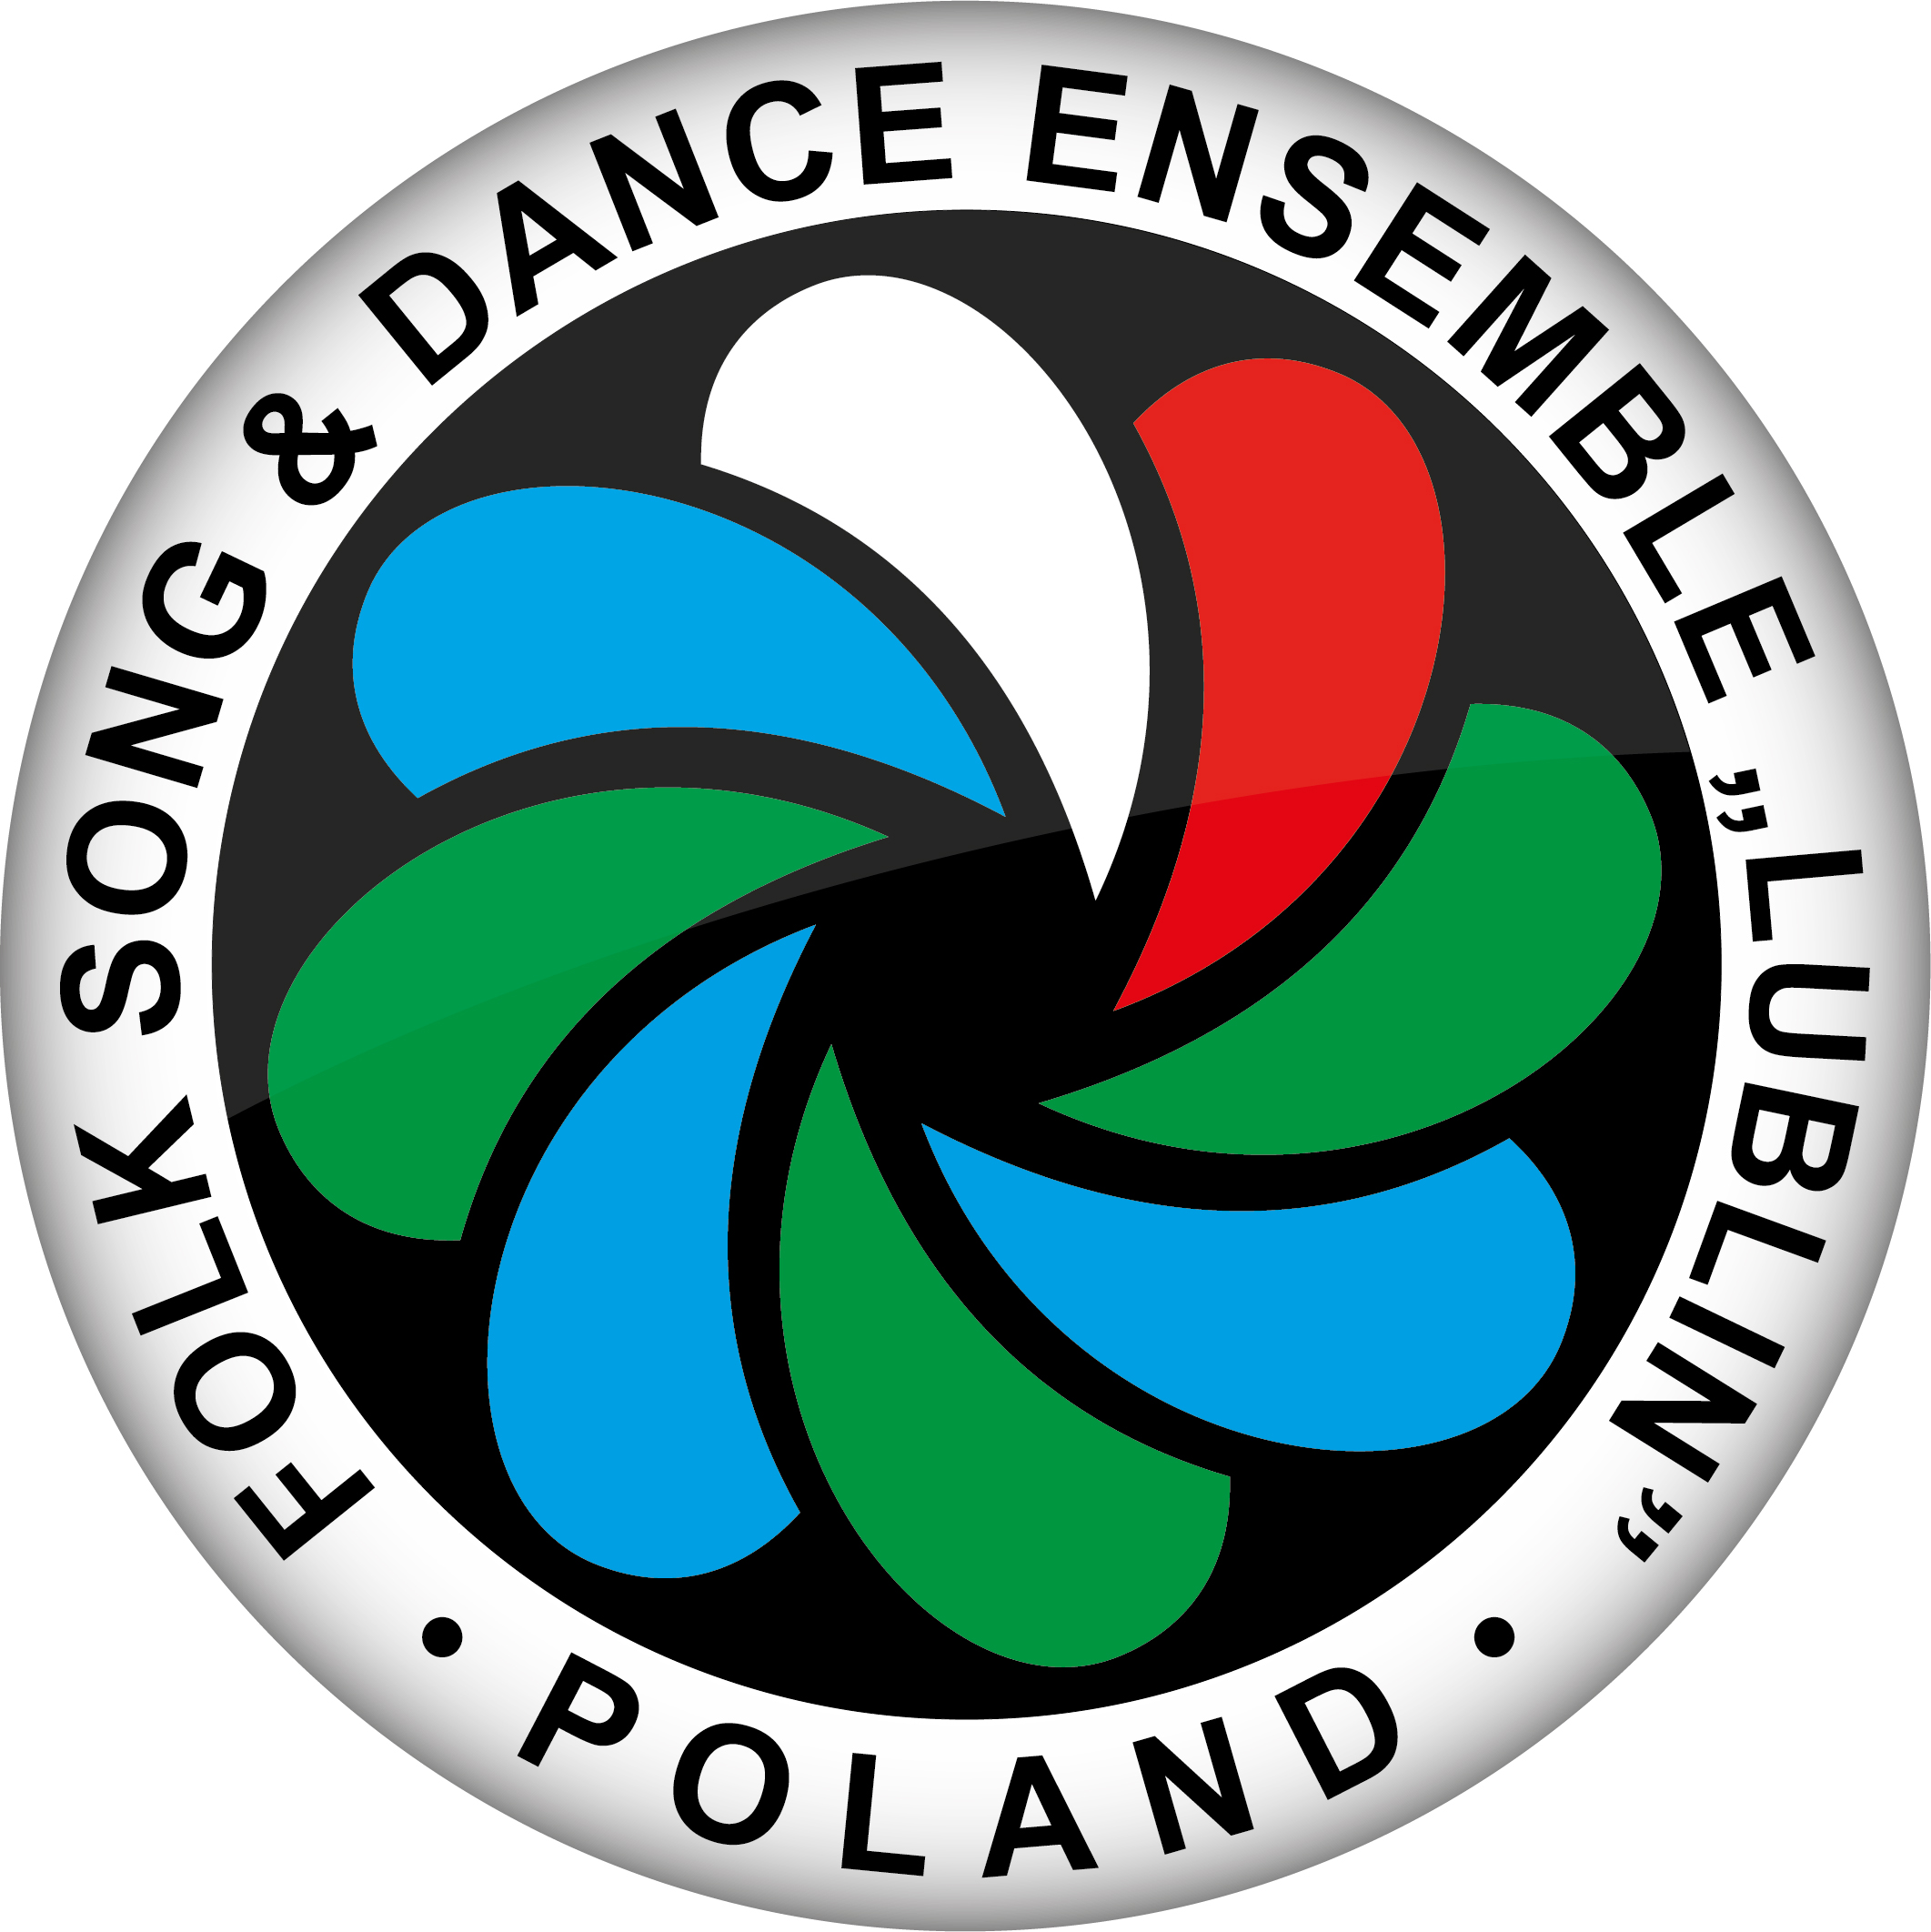

APPLICATION FORM
for artistic workshop
“ Dances of the Zamość region and dances of Biłgoraj”
Lublin 22.04.- 24.04. 2022

- Name and Surname: ………………………………………………………

- Address for contact:………………………………………..........................

…………………………………………………………………………………
- Phone: …………………… e-mail: ………………………………………
- Information for bill (Facture):
a/ full name of institution: …………………………………………………….
b/ address: ……………………………………………………………………..
- Sort of participation:
a/ with accommodation
b/ without accommodation
(* mark the right one)

Filing up this application is obligated to take part in workshop and receive the bill. Please, send this form by regular post or e-mail.
Payment consign to our account nr: 251240 1503 1111 0010 0132 5136,
Swift: PKOPPLPW
with postscript: artistic workshop “Dances of the Zamość region and dances of Biłgoraj”.

Firm stamp
Name and Surname
authorized person

Place and date

